**ASSIGNMENT-4**

**ESP32** AND **ULTRASONIC SENSOR** DATA SENDS TO IBM CLOUD

|  |  |
| --- | --- |
| **PROJECT** | IoT ENABLED - REAL TIME WATER QUALITY MONITORING AND CONTROL SYSTEM |
| **NAME** | GAYATHRI S |
| **PROJECT ID** | PNT2022TMID47600 |
| **DATE** | 22 OCT 2022 |

**QUESTION:**

**Write a code and connections in wowki for the ultrasonic sensor. Whenever the distance is less than 100cms send an “alert” to IBM cloud and display in the device receive recent events. Upload documents with wowki share link and images of IBM cloud.**

**PROGRAM:**

#include <WiFi.h>

#include <PubSubClient.h>

void callback(char* subscribetopic, byte* payload, unsigned int

payloadLength);

//-------credentials of IBM Accounts------

#define ORG "wbr1mx"//IBM ORGANITION ID

#define DEVICE_TYPE "ESP32"//Device type mentioned in ibm watson IOT Platform

#define DEVICE_ID "23456"//Device ID mentioned in ibm watson IOT Platform

#define TOKEN "?nJt2d&kHW*bIp!21z" //Token

String data3;

char server[] = ORG ".messaging.internetofthings.ibmcloud.com";

char publishTopic[] = "iot-2/evt/Data/fmt/json";

char subscribetopic[] = "iot-2/cmd/test/fmt/String";

char authMethod[] = "use-token-auth";

char token[] = TOKEN;

char clientId[] = "d:" ORG ":" DEVICE_TYPE ":" DEVICE_ID;

WiFiClient wifiClient;

PubSubClient client(server, 1883, callback ,wifiClient);

const int trigPin = 4;

const int echoPin = 18;

#define SOUND_SPEED 0.034

long duration;

float distance;

void setup() {

**Serial**.begin(115200);

pinMode(trigPin, OUTPUT);

pinMode(echoPin, INPUT);

wificonnect();

mqttconnect();

}

void loop()

{

digitalWrite(trigPin, LOW);

delayMicroseconds(2);

digitalWrite(trigPin, HIGH);

delayMicroseconds(10);

digitalWrite(trigPin, LOW);

duration = pulseIn(echoPin, HIGH);

distance = duration * SOUND_SPEED/2;

**Serial**.print("Distance (cm): ");

**Serial**.println(distance);

if(distance<100)

{

**Serial**.println("ALERT!!");

delay(1000);

PublishData(distance);

delay(1000);

if (!client.loop()) {

mqttconnect();

}

}

delay(1000);

}

void PublishData(float dist) {

mqttconnect();

String payload = "{\"Distance\":";

payload += dist;

payload += ",\"ALERT!!\":""\"Distance less than 100cms\"";

payload += "}";

**Serial**.print("Sending payload: ");

**Serial**.println(payload);

if (client.publish(publishTopic, (char*) payload.c_str())) {

**Serial**.println("Publish ok");

} else {

**Serial**.println("Publish failed");

}

}

void mqttconnect() {

if (!client.connected()) {

**Serial**.print("Reconnecting client to ");

**Serial**.println(server);

while (!!!client.connect(clientId, authMethod, token)) {

**Serial**.print(".");

delay(500);

}

initManagedDevice();

**Serial**.println();

}

}

void wificonnect()

{

**Serial**.println();

**Serial**.print("Connecting to ");

WiFi.begin("Wokwi-GUEST", "", 6);

while (WiFi.status() != WL_CONNECTED) {

delay(500);

**Serial**.print(".");

}

**Serial**.println("");

**Serial**.println("WiFi connected");

**Serial**.println("IP address: ");

**Serial**.println(WiFi.localIP());

}

void initManagedDevice() {

if (client.subscribe(subscribetopic)) {

**Serial**.println((subscribetopic));

**Serial**.println("subscribe to cmd OK");

} else {

**Serial**.println("subscribe to cmd FAILED");

}

}

void callback(char* subscribetopic, byte* payload, unsigned int payloadLength)

{

**Serial**.print("callback invoked for topic: ");

**Serial**.println(subscribetopic);

for (int i = 0; i < payloadLength; i++) {

//Serial.print((char)payload[i]);

data3 += (char)payload[i];

}

**Serial**.println("data: "+ data3);

data3="";

}

**OUTPUT:**

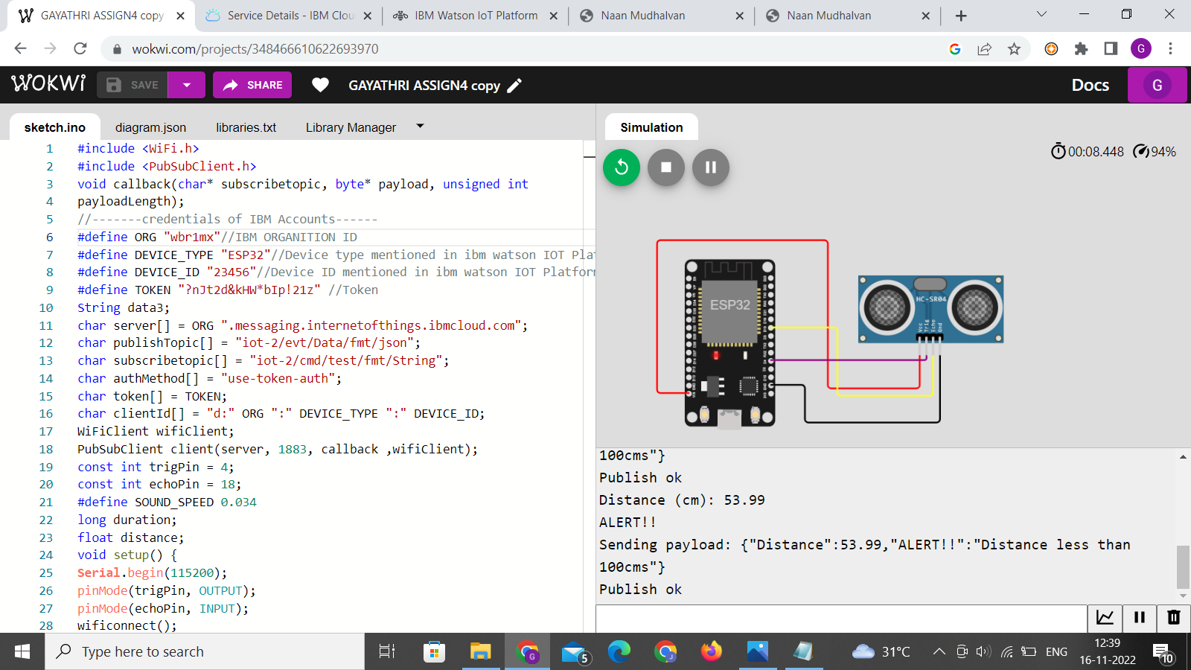

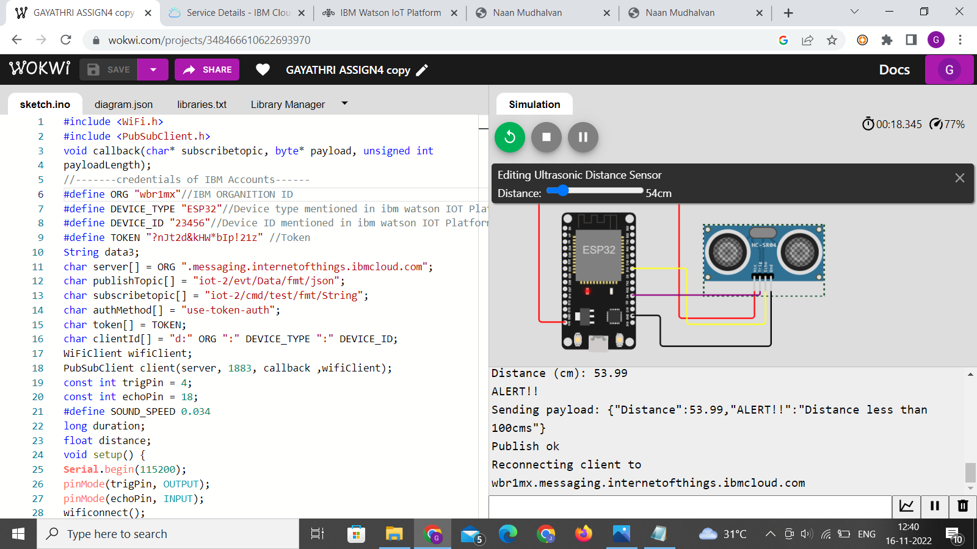

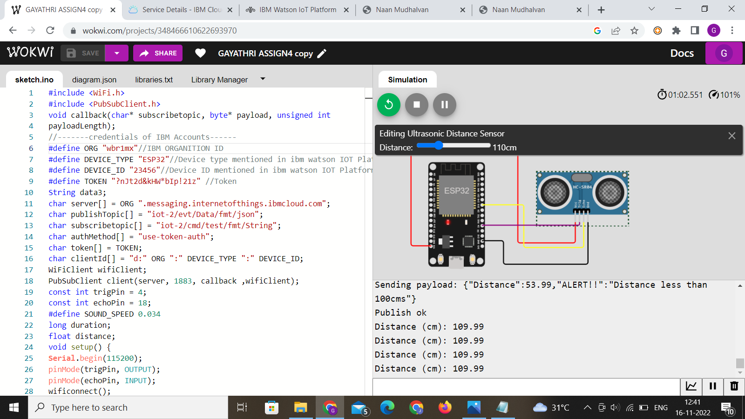

**Data uploaded to IOT Watson Platform**

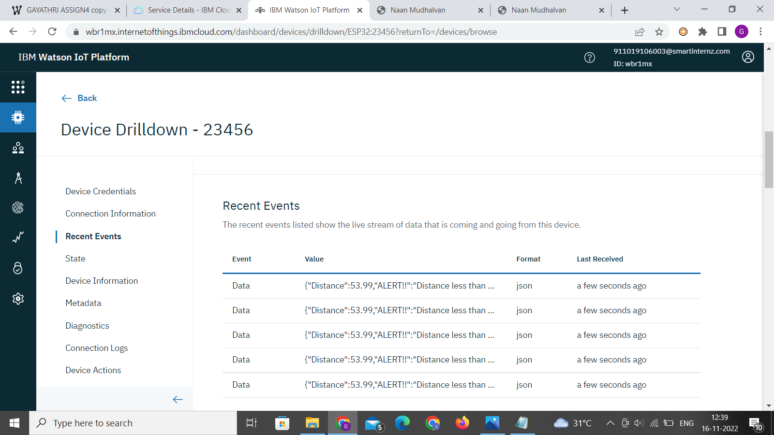

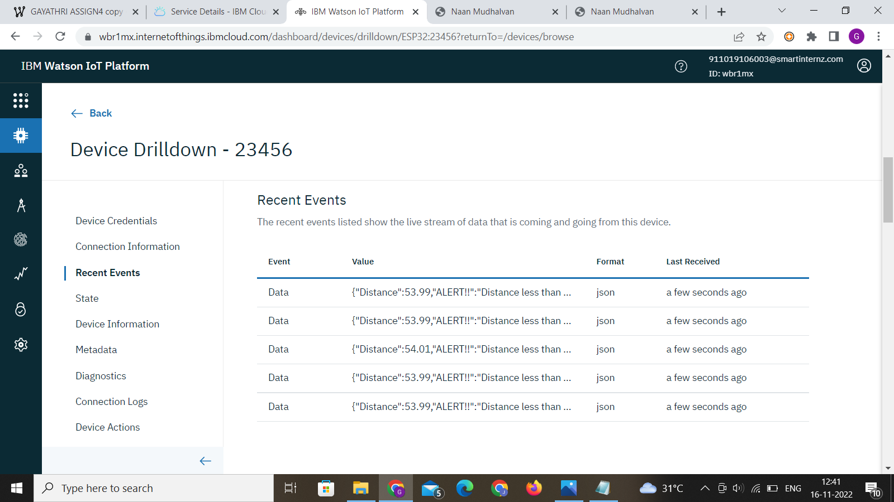

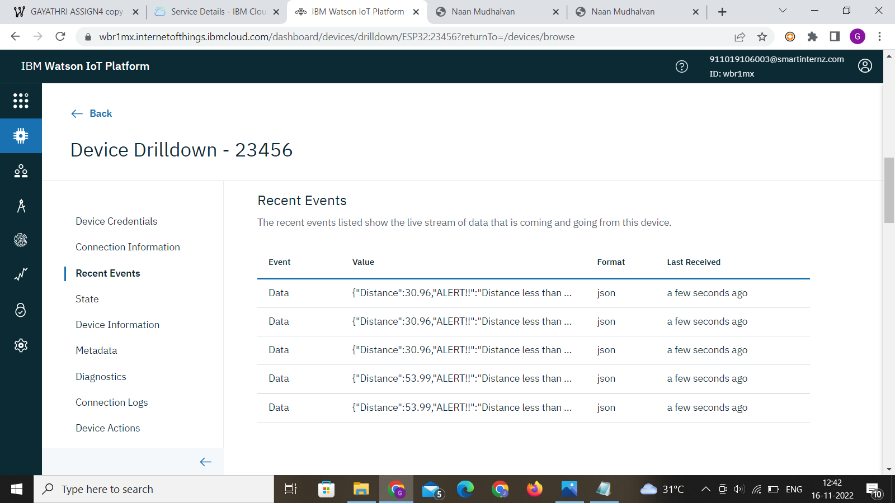

**https://wokwi.com/projects/348466610622693970**